**MCSE 1 Transferring User Profiles Lecture 2**

There are two situations when you would want to preserve a user’s profile.

1. you are replacing an old operating system with a newer operating system. For instance, you want to replace XP with Windows 7. You would like to retain all the shortcuts you have on your desktop as well as your mail settings and all the files and folders in your documents folder.

2. you are replacing an old computer with a newer model that already has an operating system installed on it. Again, you would like the user environment transferred to the new computer which may be running the same operating system or a newer operating system.

Whatever type of upgrading you are doing there are a number of steps that should be considered for any upgrade. In the worst case scenario, you might be transferring your data and settings from an old computer running an old operating system to a bare metal box with new hardware and a new operating system that you want to install.

The major steps are:

**On the old computer:**

1. Turn off or uninstall your antivirus program. Antivirus programs can interfere with programs used to prepare your system, such as Windows Easy Transfer.

2. Save your user settings, (your profile) to an external hard drive. The “My

Documents” folder tends to get very large. You should save the data in this folder to a separate folder on an external hard drive and then delete the contents of the “My Documents” folder. This will save a lot of time when saving the profile since the “My Documents” folder is part of the profile.

3. Save your data to an external hard drive. You will undoubtedly have folders not included in your profile that need to be transferred to the new system. For example, you might have a folder for your pictures that is not part of your profile.

**On the new computer:**

4. Install the new operating system.

5. Install the drivers for the hardware. If the Windows operating system does not contain a driver for a specific device it will try to load a generic driver. You can use **Device Manager** to help identify drivers that are not optimum. There will be a red “X” indicating the driver did not install or a yellow warning sign indicating the driver is not the best one to use.

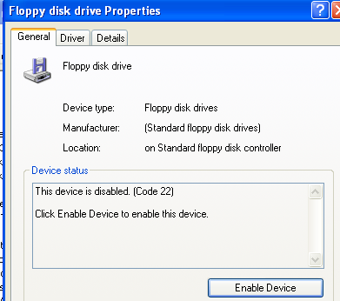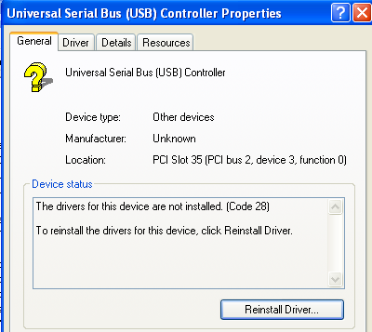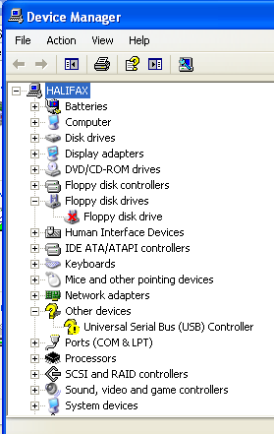

Fig. 1 Device Manager indicates which devices are having a problem

6. Install all the latest operating system updates. Without these updates, the computer will be vulnerable to attacks by hackers and viruses.

7. Transfer the user profile to the new system.

8. Copy all the folders full of personal data. These are the folders that were not transferred with the user profile folders. For instance, you might have a separate folder for spread sheets that is not part of the user profile.

9. Install all the programs that you were installed on the old computer.

10. Install Anti-virus software.

**Transferring Profiles**

How you transfer profiles between different operating systems depends upon the source and destination operating system.

**USMT (User State Migration Tool) for XP**

If you are transferring a user profile from one XP machine to another XP machine, you can use the USMT program called **Migwiz.exe** which is included in the XP operating system. (Migwiz = MIGration WIZard).

This program allowed you to save a single profile each time it was run. Therefore, if you had to transfer 4 user accounts from one machine to another, you had to run migwiz 4 times.

Because the profiles are different between XP and the operating systems that came after XP, you could not use Migwiz to transfer profiles between XP and Windows 7, 8, or 10.

Microsoft supplied a program on their web site that you could download. It was called **wet7xp_86.exe**. This program allowed you to save XP-type profiles in Windows 7/8-type profile format. You could then transfer profiles between XP and Windows 7 or Windows 8. This did not work for Windows 8.1 and

Windows 10. You have to rely on 3rd party programs like **Zinstall.**

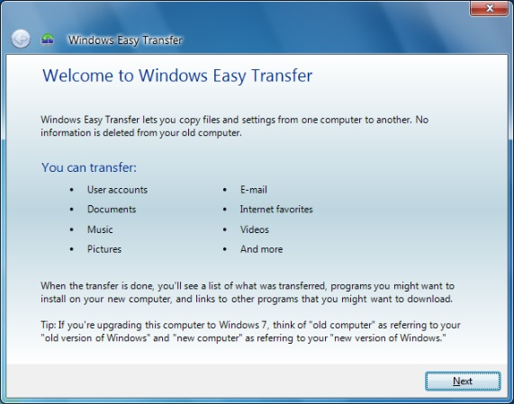**Transferring profiles in Windows 7/8 (Windows Easy Transfer)**

Windows 7 and Windows 8 provide a program called Windows Easy Transfer (WET) to automate the collection of important information contained in the user’s profile.

Figure 2 shows the things that can be transferred with Windows Easy Transfer (WET).

Fig. 2 Things that can be transferred

with the WET program

The WET program was removed with Windows 8.1. This means the user profiles can not be transferred if the operating system is Windows 8.1 or Windows 10.

Again you must rely on 3rd party programs like Zinstall.

Microsoft reasoned that with SkyDrive or OneDrive (file storage in the cloud), there was no need to worry about user profile transfers. Unfortunately, this does not solve the problem of upgrading a computer and having the user environment look the same as the old system. It merely allows data stored in the cloud to be accessible on the new computer.

Some facts about WET are:

1. WET can backup more than 1 profile at the same time. This is shown in figure 3. USMT can only backup 1 profile each time it is run.

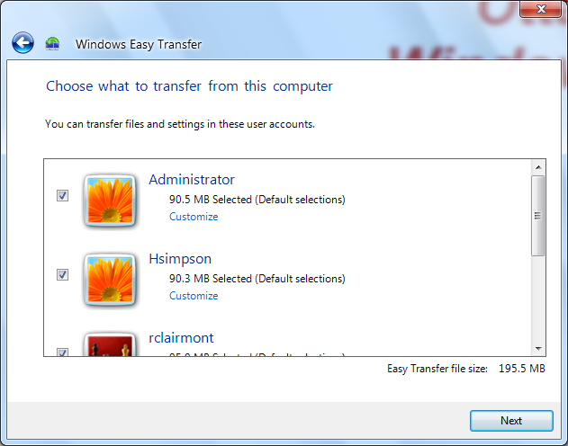

Fig. 3 WET can backup multiple profiles at the same time

2. WET must be run by an Administrator; a normal user cannot run WET.

A normal user can run UMST.

3. WET creates the new accounts and then restores the profiles for the new accounts. USMT does not create accounts.

**Note: you must manually set the password on the accounts after WET creates the accounts since WET has no option for entering the passwords.**

One thing you must be aware of when you transfer profiles from one operating system to another; if the icon on the desktop of the old operating system points to a program that does not exist in the new operating system the icon will not transfer to the new operating system.

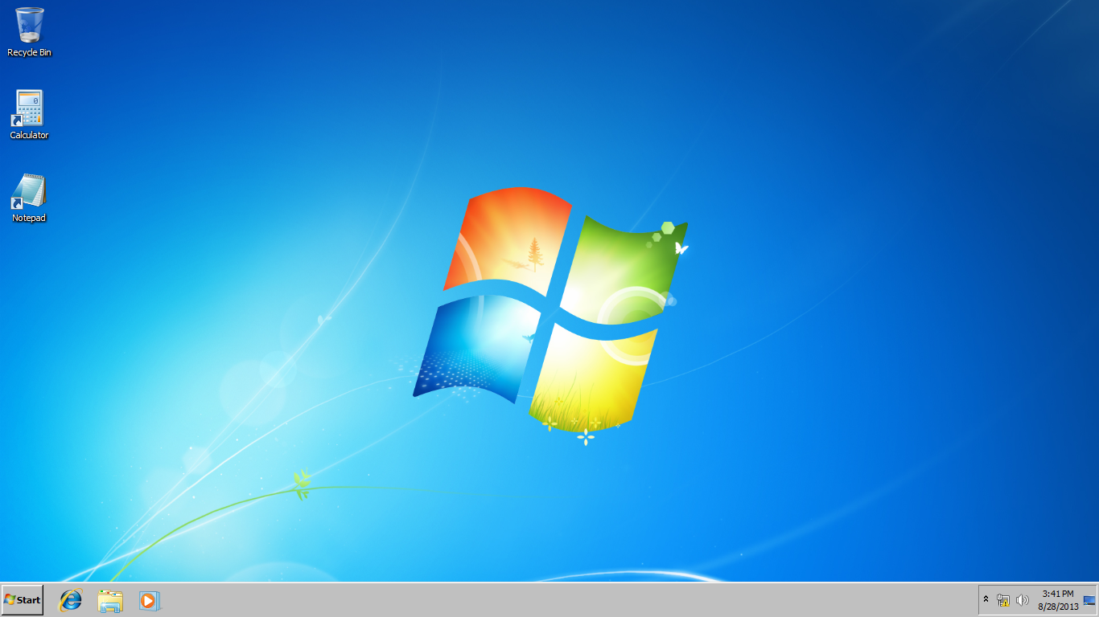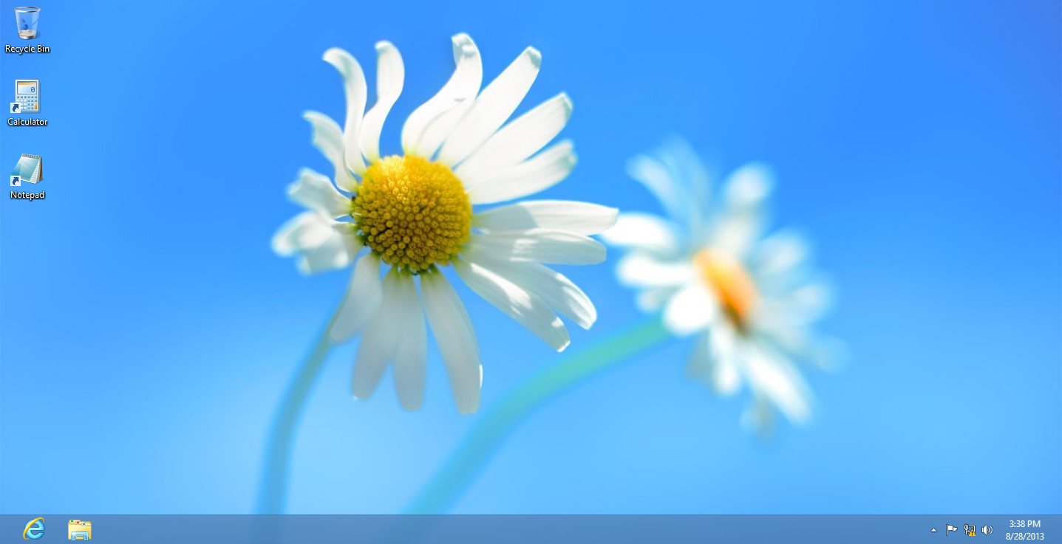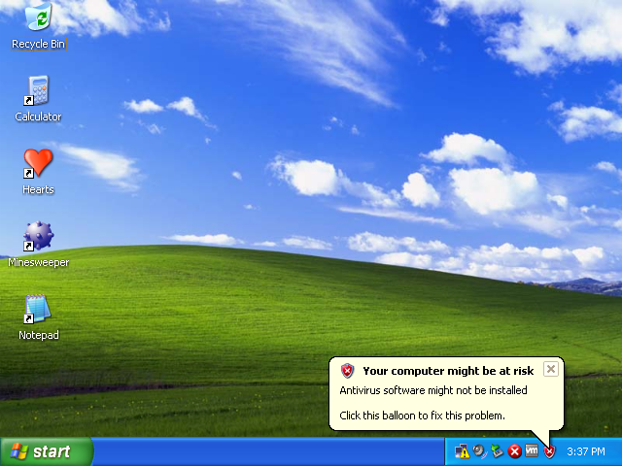

***Windows 8***

***Windows 7***

***XP***

Fig. 4 Hearts and mindsweeper did not transfer to Windows 7 and 8

On the left, Hearts and Minesweeper exist in XP but they do not exist in

Windows 7 and Windows 8 so they do not appear.